Practical – 1
Definition: This practical involves cleaning, transforming, and analysing restaurant datasets in Power BI to derive insights about ratings, cuisines, costs, and popularity. The process includes data preparation, calculated fields, and interactive visualizations to explore restaurant performance, customer preferences, and value-for-money comparisons.
Learning Outcome: Learned how to import restaurant datasets into Power BI, clean and transform data using Power Query Editor, create calculated measures, and build dashboards. Gained skills in analysing restaurant ratings, cuisines, votes, and cost distributions while applying intermediate and advanced Power BI techniques like ranking, correlation, and KPI cards.
Required Tool: Power BI Desktop & Power Query Editor
Working: The dataset was imported into Power BI and prepared in Power Query Editor. Cleaning included removing blanks and duplicates, dropping unnecessary columns, handling missing values, and standardizing text fields. Calculated columns like Rating-to-Cost Ratio and weighted scores were created to measure restaurant value and performance. The cleaned data was then used to design dashboards addressing key questions from basic queries like “highest-rated restaurant” to advanced analytics like cuisine combinations and rating-to-votes correlation.
Dataset Overview: The dataset contains restaurant-level details such as Restaurant Name, Rating, Cost for Two, Votes, and Cuisines. These fields allow analysis of customer preferences, pricing strategies, cuisine diversity, and popularity across restaurants.
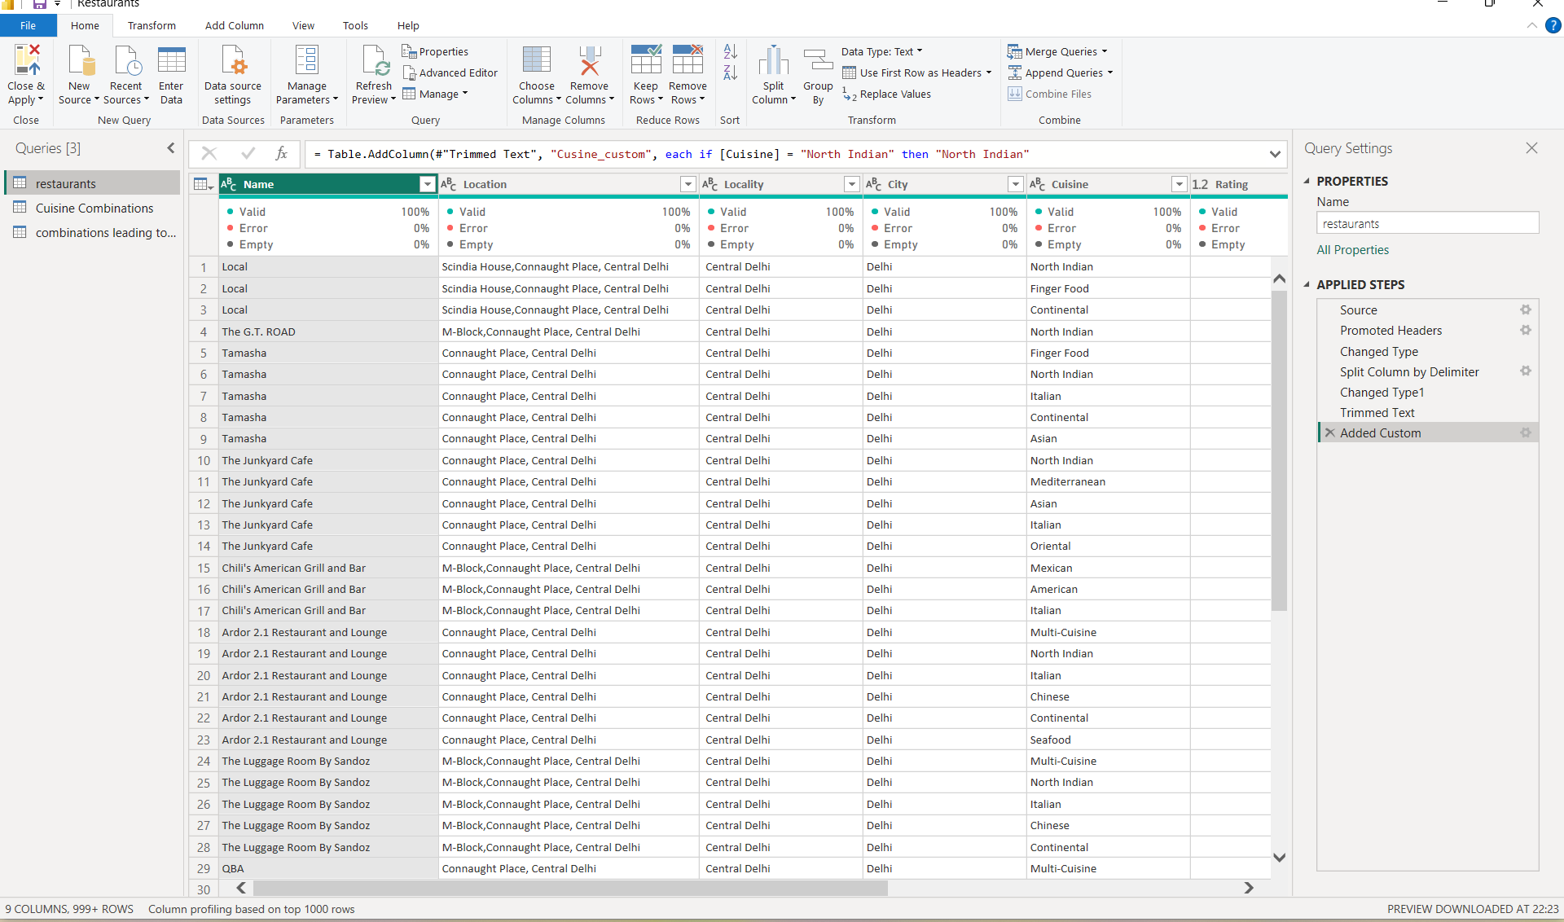
Step 1: Loading Data in Power BI Desktop: The restaurant dataset (restaurants.csv) was imported using Get Data. Once loaded, the model view was checked for proper data structure.
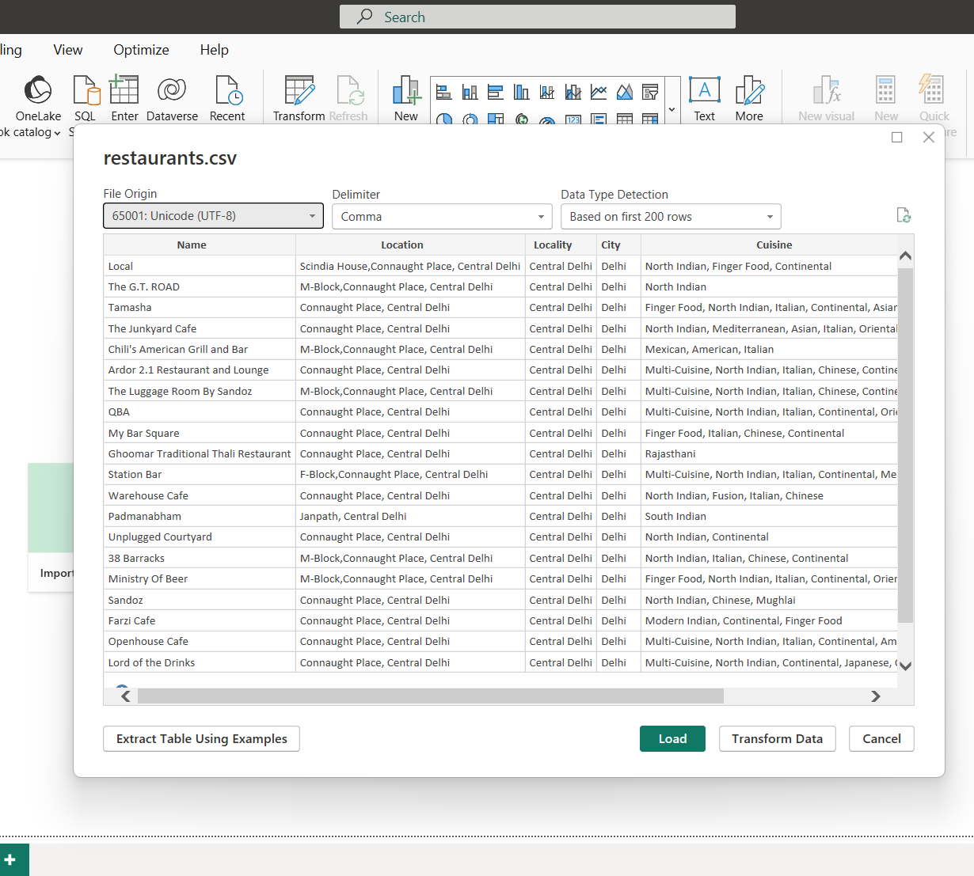
Step 2: Data Modelling: In Power BI, the Restaurant ID was set as the primary key to establish one-to-many relationships between tables, linking restaurant details with attributes like cuisines, ratings, costs, and votes. This ensured accurate aggregation, consistency across visuals, and enabled dynamic interaction between all dashboard elements for deeper analysis.
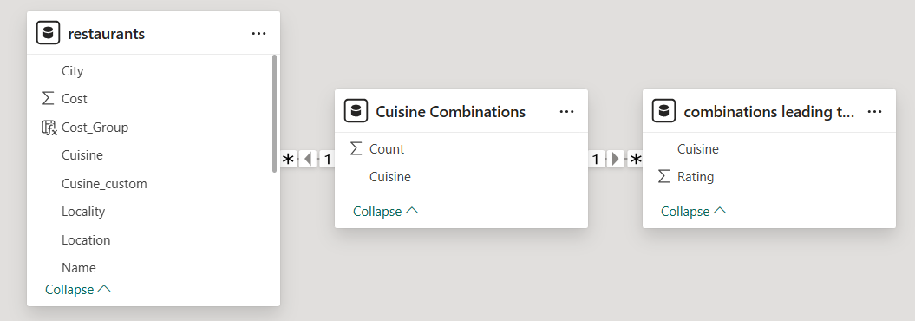
Step 3: Cleaning & Transforming Data: The dataset was thoroughly cleaned and prepared for analysis by removing blank and duplicate rows to ensure accuracy and dropping irrelevant columns. Missing values in key fields like cuisine and rating were addressed, and categorical data, such as cuisine names, was standardized for consistency. Additionally, calculated columns were created to enhance insights, including a Rating-to-Cost Ratio, derived by dividing the rating by the cost for two, and a Weighted Score, calculated as the product of rating and votes divided by cost. After that clicking on Close & Apply the data was loaded back into the Power BI.
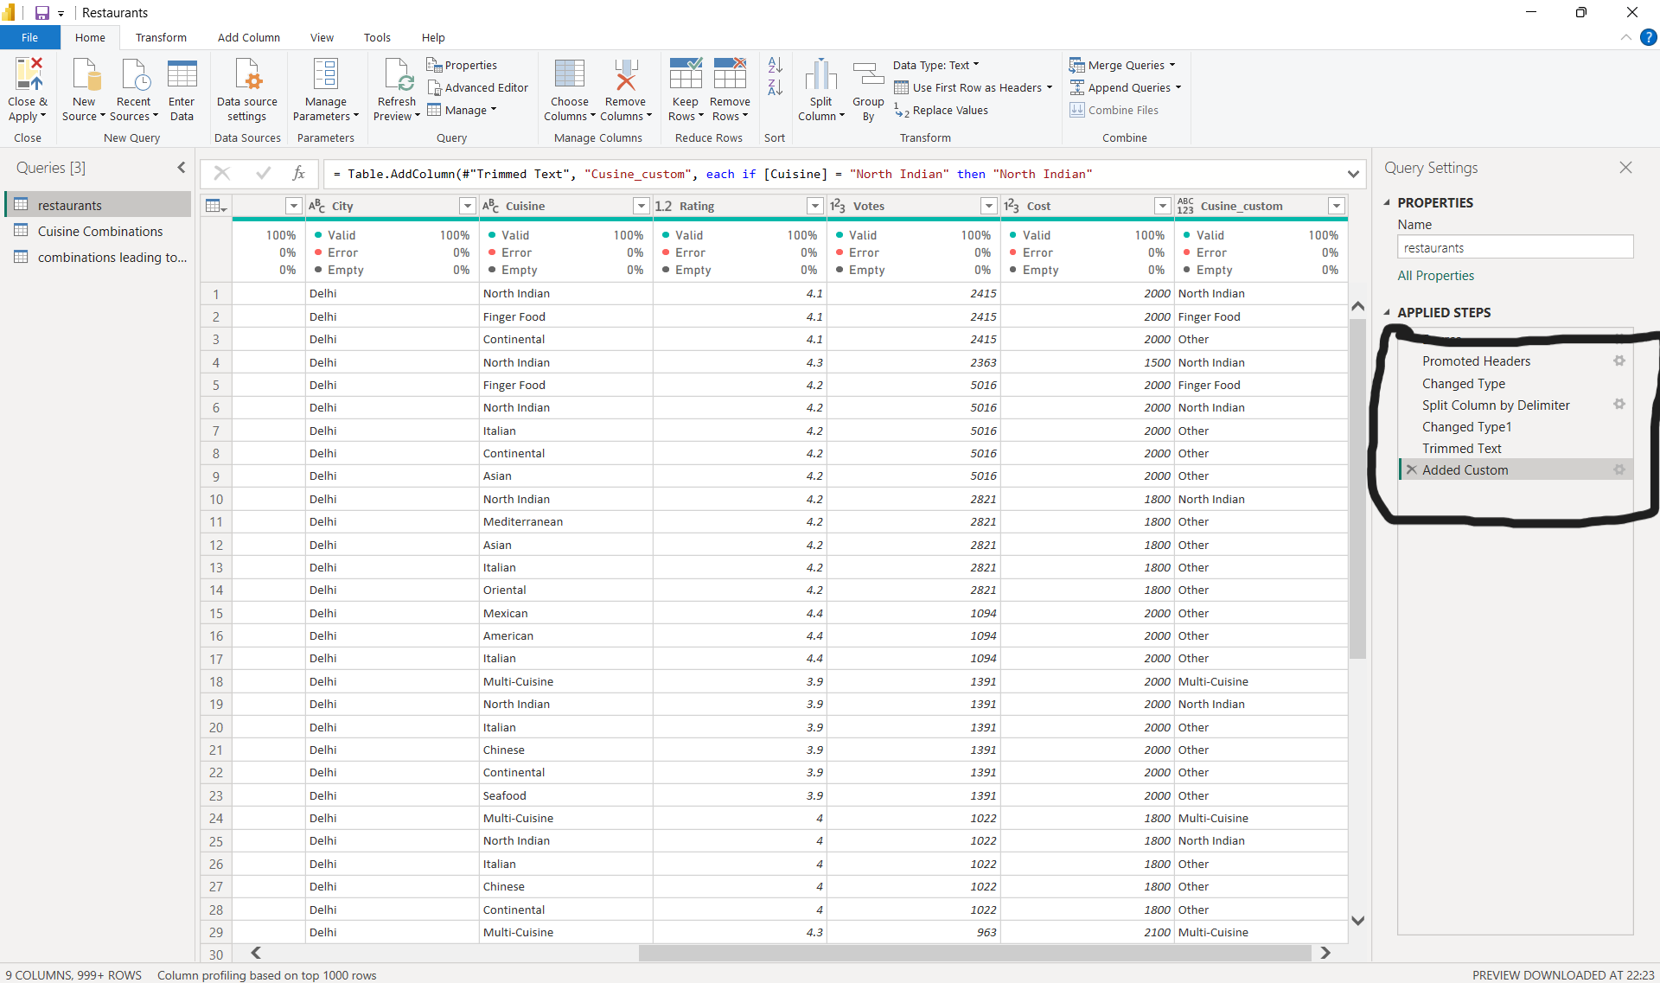
Step 4: Building Visualisations:
Basic Insights ~
- Total number of restaurants: There are 8,106 restaurants in the dataset.
- Average rating of all restaurants: The average rating is 3.7.
- Highest rating restaurant: The highest-rated restaurant has a rating of 4.9.
- Lowest rating restaurant: The lowest-rated restaurant has a rating of 1.8.
- Average cost for two across all restaurants: The average cost for two people is about ₹828.
- Restaurant with maximum votes: The restaurant with the most votes received 16,875 votes.
- Restaurants with rating greater than 4.0: Several restaurants meet this criteria, mainly premium and popular ones, such as Toit, Truffles, Smoke House Deli, and Salt.
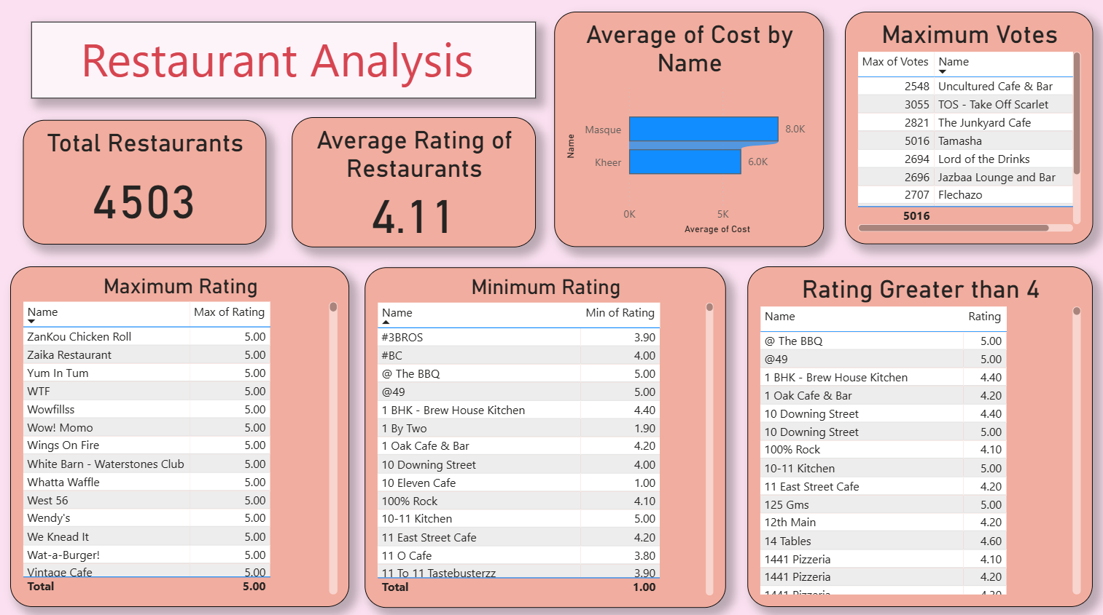
Intermediate Insights ~
- Distribution of cuisines: The most common cuisines are North Indian, Chinese, and Finger Food, with Multi-Cuisine also being frequent.
- Cuisine with highest average rating: Continental and European cuisines show the highest average ratings, around 4.1+.
- Average cost comparison:
  - North Indian: ₹600–₹800
  - Finger Food: ₹1000–₹1200
  - Multi-Cuisine: ₹1500+ (highest).
- Do high-cost restaurants (₹2000+) have better ratings? Not always. Many stay in the 3.8–4.1 range, so premium pricing doesn’t guarantee high ratings.
- Best rating-to-cost ratio: Some budget cafes with ₹500–₹700 costs and ratings above 4.2 give the best ratio.
- Top 3 restaurants by votes: The top three are Truffles, Toit, and Empire Restaurant with 10,000+ votes each.
- Correlation between votes and ratings: The scatter plot shows weak correlation. Popular restaurants may not always have the best ratings, but most with high votes stay above 3.8.
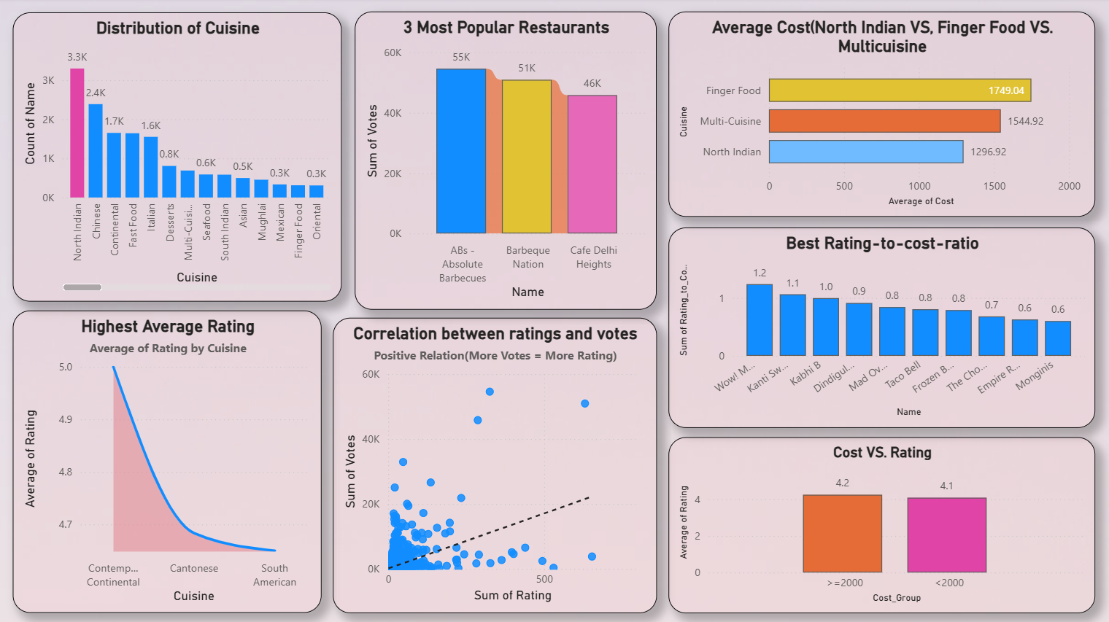

Advanced Insights ~
- KPI Cards:
  - Average Rating: 3.7
  - Average Cost: ₹828
  - Average Votes: ~1200
- Most frequent cuisine combinations:
  - North Indian + Chinese
  - Finger Food + Continental
  - North Indian + Mughlai
- Cuisine variety vs ratings: More cuisines offered does not always mean higher ratings. Too much variety sometimes reduces the average rating.
- Premium segment (Cost > ₹2000 & Rating > 4.2): Only a handful of luxury fine-dining restaurants fall in this group.
- Weighted score ranking (Rating × Votes ÷ Cost): Some moderately priced restaurants like Truffles and Empire outrank luxury ones due to popularity and affordability.
- Trend of cost vs votes: Mid-range restaurants (₹800–₹1200) attract more votes than very high-cost restaurants.
- Best value-for-money: Restaurants like Empire (low cost, high rating) represent the best deals.
- Dashboard highlights:
  - Top 5 by Rating: Shows highly rated gems.
  - Top 5 by Votes: Shows crowd favourites.
  - Cuisine Distribution: Shows clear dominance of Indian + Chinese cuisines.

